Chapter-1
Introduction

A major project is a very important part of our academic course. It is something where we are asked to create a complete product, which can be either software or hardware depending on the idea. But in actual, it is not only about making a project just for marks, it is more about understanding how things work in a real situation.
During our studies, we learn many concepts in theory, but we do not always get a chance to apply them. This is where the major project becomes useful. It gives us an opportunity to use that knowledge in a practical way. At the beginning, it may feel a bit confusing, because things do not always go as planned. But slowly, as we keep working on it, we start understanding better.
It also helps students to learn new things on their own. Sometimes we have to search for solutions, try different approaches, and even make mistakes before getting the correct result. That whole process actually teaches more than just reading from books.
In this project, students get a chance to develop something from scratch. First, we think about the idea, then we plan how to implement it, and after that we start building it step by step. Because of this, we understand how a complete system is developed, not just a small part of it.
Another important thing is that it builds confidence. When we see that something we made is actually working, it feels good. It also teaches us how to manage time, because we have to complete the project within a given deadline. Overall, it is a very useful experience for students.

Project Introduction
Even nowadays, in many institutions, a lot of work is still done manually. Activities like marking attendance, sharing notices, and managing timetables are often handled without using any proper system. This method takes time and sometimes becomes difficult to manage, especially when the number of students is large.
If we look at the current situation, students and teachers both have many tasks in their daily routine. Because of this, managing everything manually becomes confusing and tiring. Sometimes information gets delayed, and sometimes students do not receive it properly.
To solve these problems, I have developed a project called Smart Campus. The idea behind this project is simple — to make campus-related work easier by using a digital platform.
This system provides features like attendance, notices, timetable, assignments, and other updates in an online manner. Instead of depending on manual work, everything can be accessed through one system.
One of the main advantages of this system is that all the information is available at one place. Students and teachers do not have to search in different places. They can simply log in and check whatever they need.
This makes the system more convenient and also reduces confusion. It also saves time, which is very important in daily routine.

Problem Statement
In many institutions, basic activities like sharing notices, maintaining timetable, and marking attendance are still done manually. This process takes a lot of time and is not always reliable.
Sometimes, students do not get information at the right time. Because of this, they may miss important updates like assignments or notices. This can create problems for them later.
There can also be confusion in communication. Not every student feels comfortable asking questions directly. Sometimes they may hesitate, or sometimes they may not even know whom to ask. Because of this, information does not always reach clearly.
When there are many students, managing everything manually becomes even more difficult. There are chances of mistakes, like missing entries or incorrect data.
In today’s time, where most things are becoming digital, such manual systems are not very effective. So, there is a need for a system that can handle these activities in a better and more organized way.

Need of the Project
There are already some platforms available that manage campus activities, but they are not always easy to use. Some of them only provide one or two features, so users have to switch between different platforms for different tasks.
Another problem is that some systems are too complex. Their interface is not simple, and new users may find it difficult to understand. Because of this, people sometimes avoid using them.
So, the idea behind this project is to bring everything into one system. Instead of using multiple platforms, users can find everything in one place.
This project also focuses on making things simple. The system is designed in such a way that students and teachers can use it without much difficulty.
One more important point is communication. Sometimes students hesitate to ask questions directly. With this system, they can check notices, assignments, and other updates on their own.
This helps in saving time and also makes things clearer. Overall, the system makes daily activities easier and more organized.

Objective
The main objective of the Smart Campus project is to create a system that can make campus work easier and more organized.
The system aims to:
- To develop a platform where all campus-related activities can be managed in one place, so users do not have to depend on multiple systems.
- To reduce manual work and save time for both students and teachers.
- To provide easy access to assignments and study materials, so students can use them whenever needed.
- To create role-based dashboards so that each user gets access according to their role.
- To provide an online attendance system instead of using registers.
- To help teachers and students communicate easily through the system.
- To provide notices and updates in a clear and organized way so that no important information is missed.
- To include an AI-based assistant that can help students with basic queries.
These objectives are focused on making the system simple, useful, and easy to use in daily life.

Features of the Project
The Smart Campus system includes different features that help in managing daily campus activities in a simple way. The aim is to make the system easy so that users do not face problems while using it.
- The system provides login and registration for both students and teachers. This helps in keeping the system secure and allows only valid users to access it.
- There are separate dashboards for students and teachers. Because of this, each user only sees the options that are useful for them, which makes it less confusing.
- Attendance can be managed online. Teachers can mark it easily, and students can check their attendance whenever they want.
- A notice section is available where important updates can be shared. Students can simply check the system instead of going to notice boards.
- The system allows uploading and submitting assignments. This makes it easier for both teachers and students to manage work.
- Students can access notes through the system. This helps them during studies, especially when they need material quickly.
- An AI-based assistant is included to help students with basic questions. It provides quick answers and guidance when needed.
- The timetable is available online, so students can check it anytime without carrying anything extra.
- All the information is available at one place, which makes it easy to access and manage.
- The interface of the system is simple, so even someone using it for the first time can understand it without much difficulty.
Overall, these features make the system more convenient and help in managing campus work in a better way.

Chapter – 2
Tools and Technology

Chapter – 2
Tools and Technology

2.1 Introduction to Tools and Technology
Tools and technology play an important role in the development of any project. They help in building, managing, and running the system in a proper way. Different types of tools are used for designing, coding, storing data, and testing the application.
In simple terms, tools and technology are the resources that help developers create a working system. Without them, it would be very difficult to develop a project efficiently.
In this project, different technologies are used for frontend, backend, database, and development environment.

2.2 Technology Used
2.2.1 Frontend

Frontend is the part of the application that users can see and interact with. It includes everything that appears on the screen such as buttons, forms, pages, and layouts.
In simple words, frontend is the user interface of the system. It is responsible for how the application looks and how users interact with it.
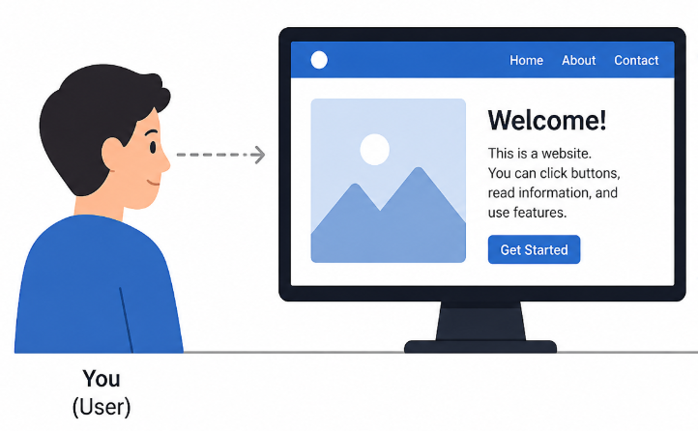

2.2.2 Technology Used – React.js
React.js is used for developing the frontend part of this project.
React.js is a JavaScript library used to build user interfaces. It helps in creating interactive and dynamic web pages. It works using components, which means different parts of the UI can be created separately and reused.

2.2.3 Use of React.js in Project
In this project, React.js is used to design different pages like login page, dashboard, and other user interface components. It helps in making the system interactive and easy to use.
For example, forms, buttons, and display sections are created using React. It also helps in updating data on the screen without refreshing the whole page.

2.2.4 Features of React.js
React.js provides several useful features such as reusable components, fast rendering, and better performance. It allows developers to divide the UI into smaller parts, which makes the code easier to manage.

2.2.5 Advantages of React.js
React.js helps in making the application faster and more efficient. It also saves time because the same code can be reused. It is easy to maintain and widely used in modern web applications.

2.3 Backend
2.3.1 What is Backend?
Backend is the part of the system that works behind the screen. It handles data processing, server operations, and communication between frontend and database.
Users cannot directly see the backend, but it is responsible for how the system works internally.
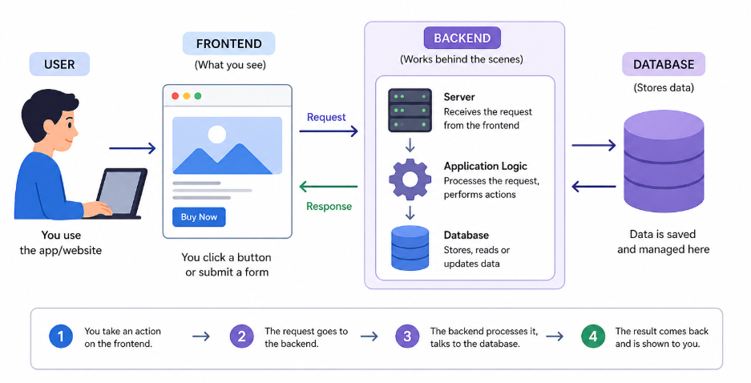

2.3.2 Technologies Used – Node.js and Express.js
Node.js and Express.js are used for backend development in this project.
Node.js allows JavaScript to run on the server side. It is used to handle requests and manage data.
Express.js is a framework that works with Node.js. It helps in handling routes and making backend development easier.

2.3.3 Use of Backend in Project
In this project, Node.js and Express.js are used to handle user requests like login, data submission, and fetching information from the database.
Whenever a user performs an action, the request is processed by the backend and the required response is sent back.

2.3.4 Features of Backend Technologies
Node.js works in an asynchronous way, which means it can handle multiple tasks at the same time. Express.js helps in organizing backend code and managing routes easily.

2.3.5 Advantages of Backend Technologies
These technologies provide good performance and help in handling multiple users. They also make it easier to connect frontend with database.

2.4 IDE (Integrated Development Environment)
2.4.1 What is IDE?
IDE is a software application that is used for writing and managing code. It provides tools like code editor, debugging, and extensions that make development easier.

2.4.2 IDE Used – Visual Studio Code
In this project, Visual Studio Code (VS Code) is used as the development environment.
VS Code is a lightweight and easy-to-use editor that supports multiple programming languages. It also provides useful extensions which help in coding.

2.4.3 Use of VS Code in Project
VS Code is used to write both frontend and backend code in this project. It helps in organizing files and running the application.

2.4.4 Features of VS Code
VS Code provides features like syntax highlighting, debugging tools, and extension support. It also makes coding faster and easier.

2.4.5 Advantages of VS Code
It is easy to use and customizable. It supports many programming languages and helps in efficient development.

2.5 Database
2.5.1 What is Database?
A database is used to store and manage data in a structured way. It allows data to be stored, accessed, and updated easily.

2.5.2 Database Used – MySQL
In this project, MySQL is used as the database.
MySQL is a database management system that stores data in tables. It is widely used for web applications.

2.5.3 Use of MySQL in Project
MySQL is used to store information like student details, attendance, assignments, and notices.
Whenever data is needed, it is fetched from the database and displayed to the user.

2.5.4 Features of MySQL
MySQL provides structured data storage, security, and fast performance. It helps in organizing data properly.

2.5.5 Advantages of MySQL
It is easy to use and reliable. It supports multiple users and provides good performance.

